**Uber Ride Analysis**

**Contents**

Introduction 1

Data Overview 1

Key Findings 2

**A.** **Ride Trends Analysis** 2

**B.** **Ride Distance Analysis** 4

**C.** **Weekday vs Weekend Rides** 5

Business Implications 6

Conclusion and Recommendations 6

# Introduction

This report is all about my analysis of Uber ride patterns, peak travel times, and ride frequency trends to understand customer behavior. Using Python, Pandas, Matplotlib, Seaborn, and Plotly, I have explored the data through various visualizations and insights

The following aspects are analyzed:

1. Rides Per Month
2. Rides Per Weekdays
3. Peak Ride Hours
4. Distribution of Ride Purpose
5. Peak Hour Comparison on Weekdays and Weekends
6. Ride Frequency by Hour on a day of the week
7. Miles Covered by Drivers Per Month

# Data Overview

* The dataset contains Uber ride details, including trip start time, end time, miles covered, and purpose of travel.
* The dataset has missing or inconsistent values, which are handled through data cleaning and transformations such as date-time conversion and weekday classification.
* Data visualizations are created to derive meaningful insights.

# Key Findings

## **Ride Trends Analysis**

* The highest number of rides were taken in December, with more than 140 rides.
* On a weekly basis, the highest number of rides were taken on Friday, indicating increased travel before the weekend.
* Peak hours are between 1 PM and 6 PM (13:00 – 18.00), showing high demand during afternoon hours.
* On average, 15 to 20 rides are taken in between 2 PM and 5PM (14:00 – 17:00) from Monday till Saturday.
* A significant number of customers did not specify the purpose of their travel, making it challenging to analyze trip intent fully.

**Ride per month:**

The bar chart below shows the distribution of Uber rides per month, highlighting the busiest travel periods.

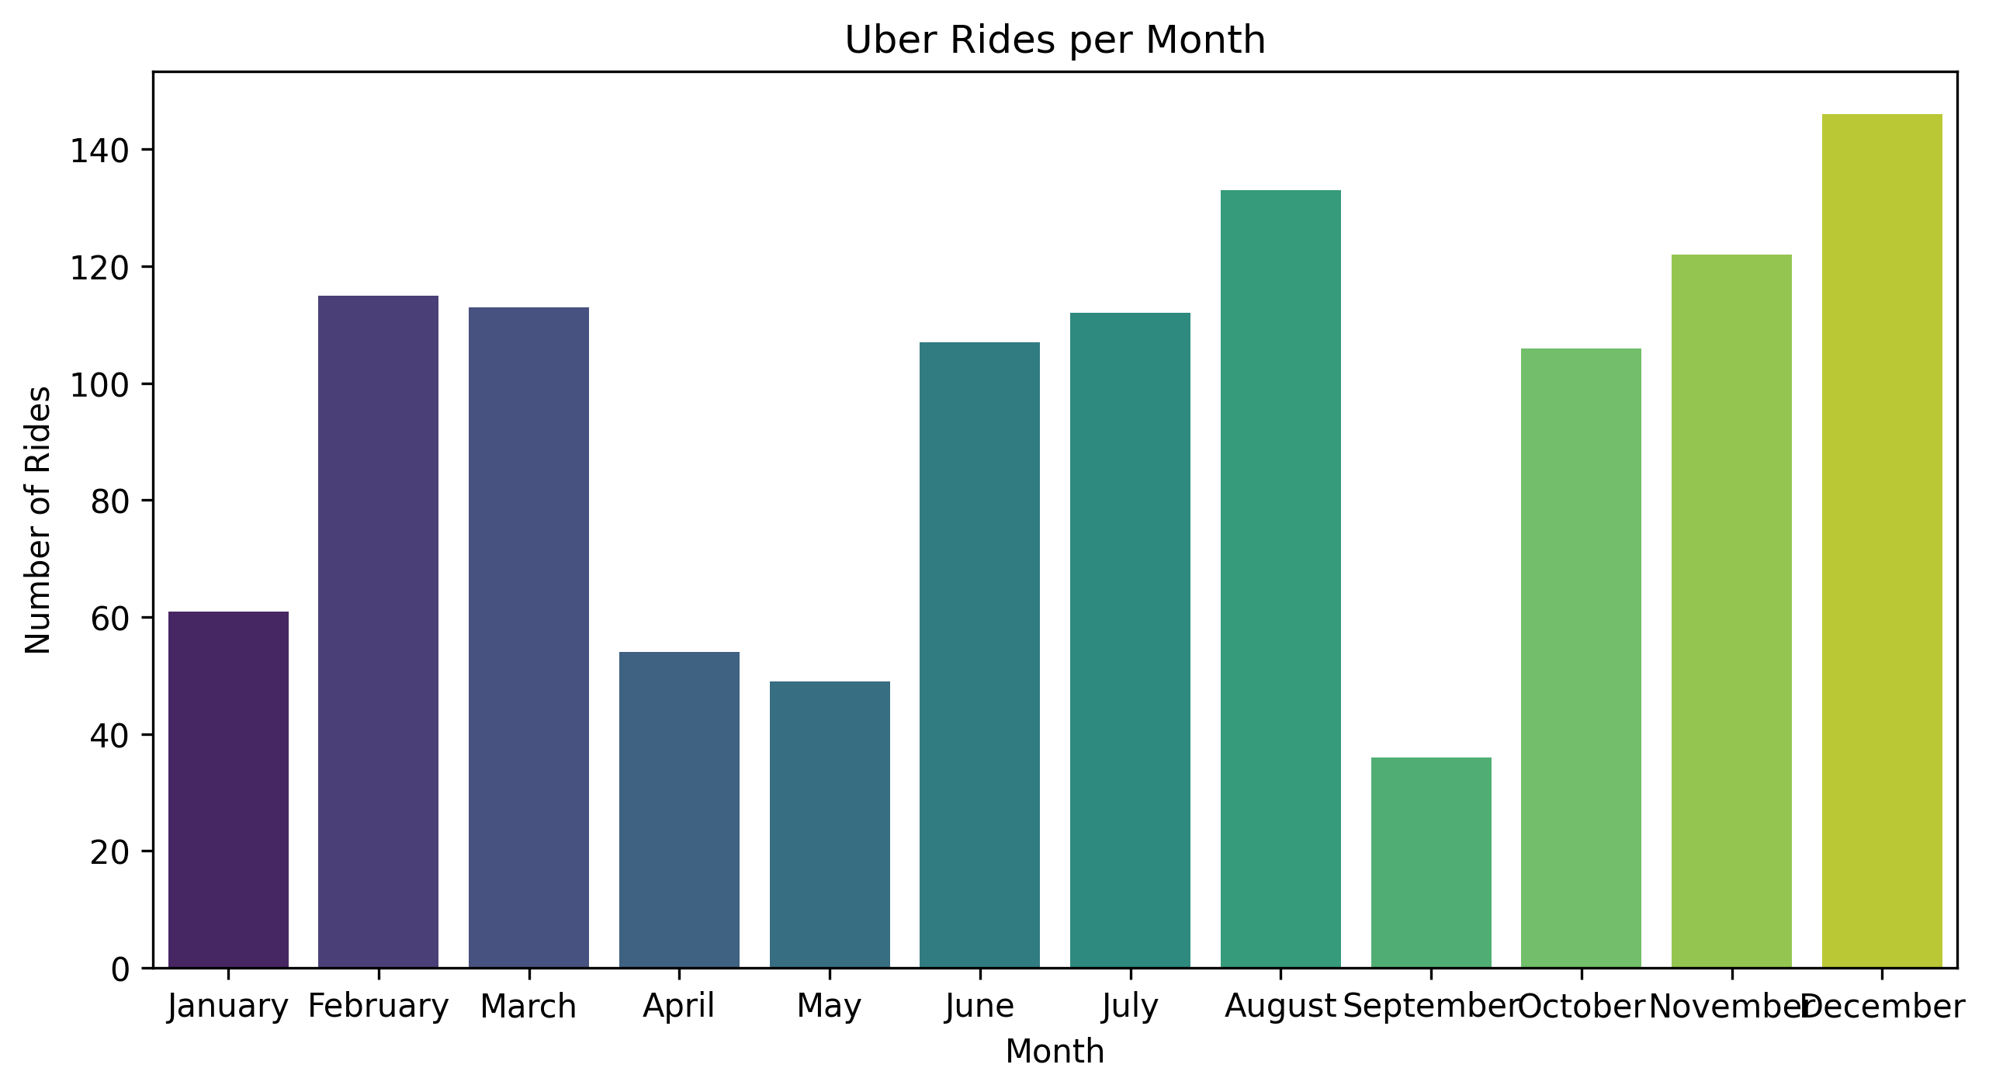

**Ride per Day:**

The bar chart below shows the distribution of Uber rides per day in a week, highlighting the highest number of rides taken on a particular day.

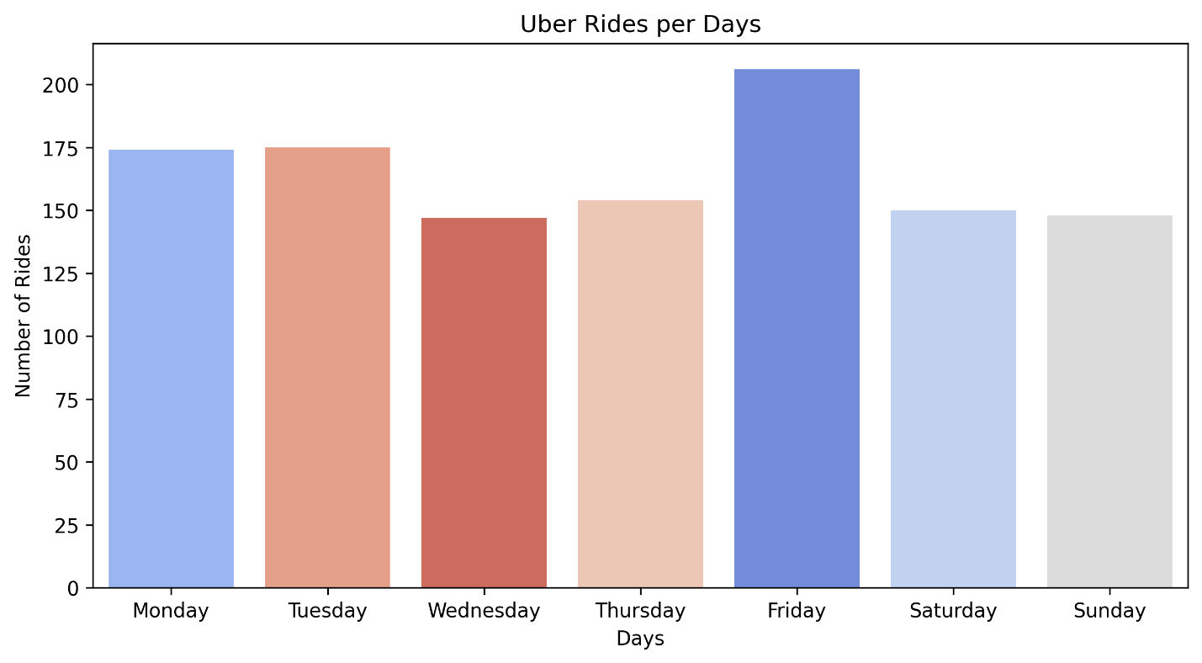

**Ride per Hour in a Day:**

The line plot below shows the average number of Uber rides taken throughout the day, highlighting the peak hours with the highest number of ride demand.

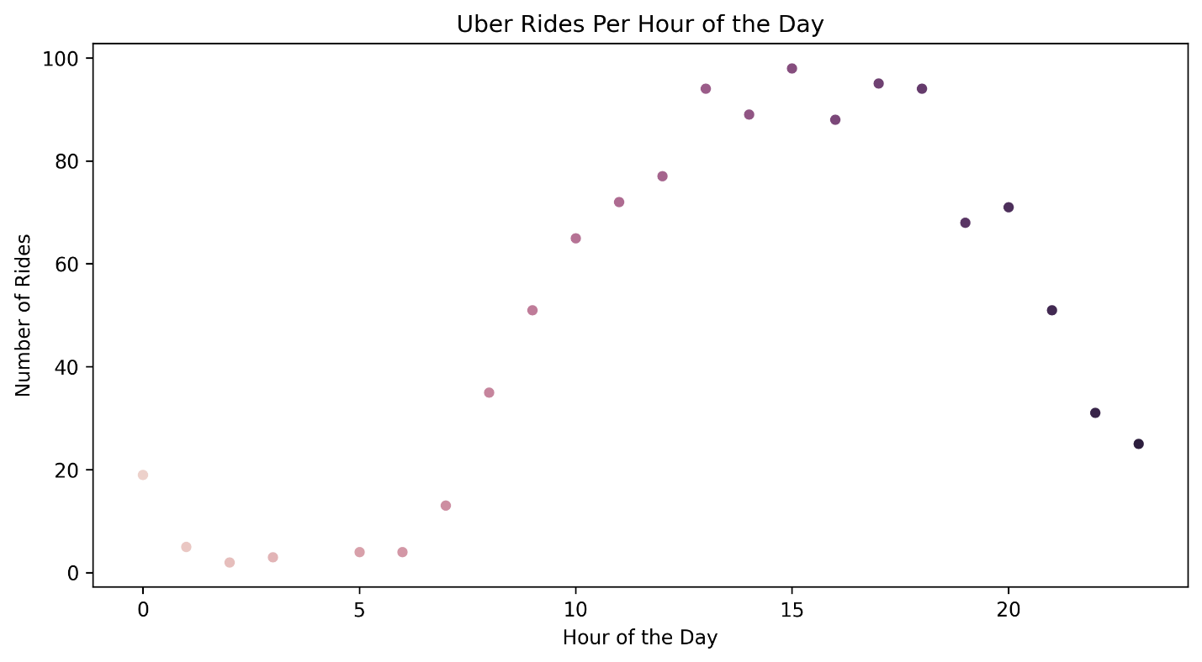

## **Ride Distance Analysis**

* Though the highest number of rides was recorded in December, October and March had the longest total miles traveled, with 1,810 miles, and 1,693 miles.
* This suggests that customers traveled longer distances during these months, possibly due to vacation periods or long weekends when they returned to their hometowns.
* The average miles per trip varies across months, with some months showing longer ride distance despite fewer trips.

**Miles covered per month**

This bar chart shows the total miles covered by the Uber rides each month, highlighting the month with the highest distance traveled.

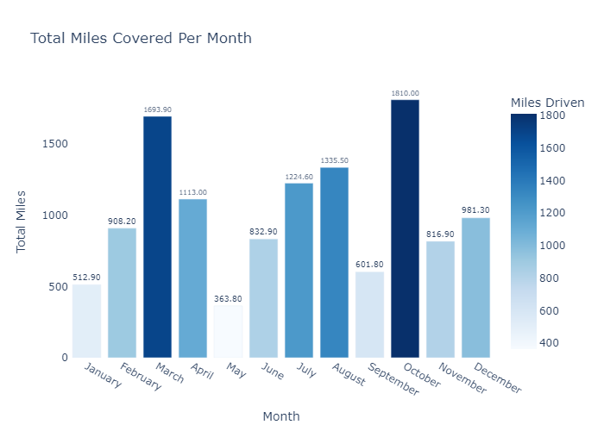

## **C.** **Weekday vs Weekend Rides**

* Weekday rides are higher compared to weekend rides, suggesting that Uber demand is primarily work related.
* Analyzing on an hourly basis, ride frequency between 00:00 and 06:00 remains similar on both weekdays and weekends, likely due to:
* Late night travelers (flights, long-distance travel).
* Night shift workers (IT professionals, hospital staff, security).
* Social events (parties, night life).
* Ride demand increases after 06:00 AM on weekdays, driven by working professionals.
* On Weekends, ride demand remains low in the morning but peaks in the evening.

**Weekday vs Weekend ride patterns:**

The line graph below highlights the difference in the ride counts between weekdays and weekends for each hour of the day.

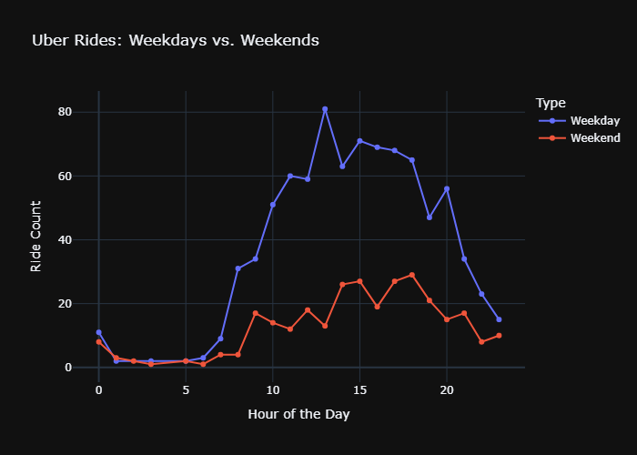

# Business Implications

* **Strategic Night Fare Pricing:** Adjust pricing strategies to encourage more rides during **late-night hours**, increasing overall ride counts.
* **Optimized Driver Allocation:** Assign more drivers on **Fridays and afternoons** to meet peak demand, improving both customer experience and **Uber’s service efficiency.**
* **Implement a Subscription Model:** Introduce a subscription plan for frequent Uber users, offering benefits like discounted fares and priority pickups. This aligns with the observed **consistent ride demand between 2 PM and 4 PM.**
* **Driver Incentive Program:** Introduce a **ride points** system where customers can rate and provide feedback on drivers. Allowing top-rated drivers to access **exclusive Uber benefits, fuel discounts, or bonus incentives**, encouraging them to stay on the platform.

# Conclusion and Recommendations

This analysis provides key insights into Uber ride trends, peak hours, and customer behavior. Future studies can include **geospatial data (latitude/longitude) to analyze location-based trends.** Additionally, integrating **weather and traffic conditions** could enhance the accuracy of ride demand predictions.